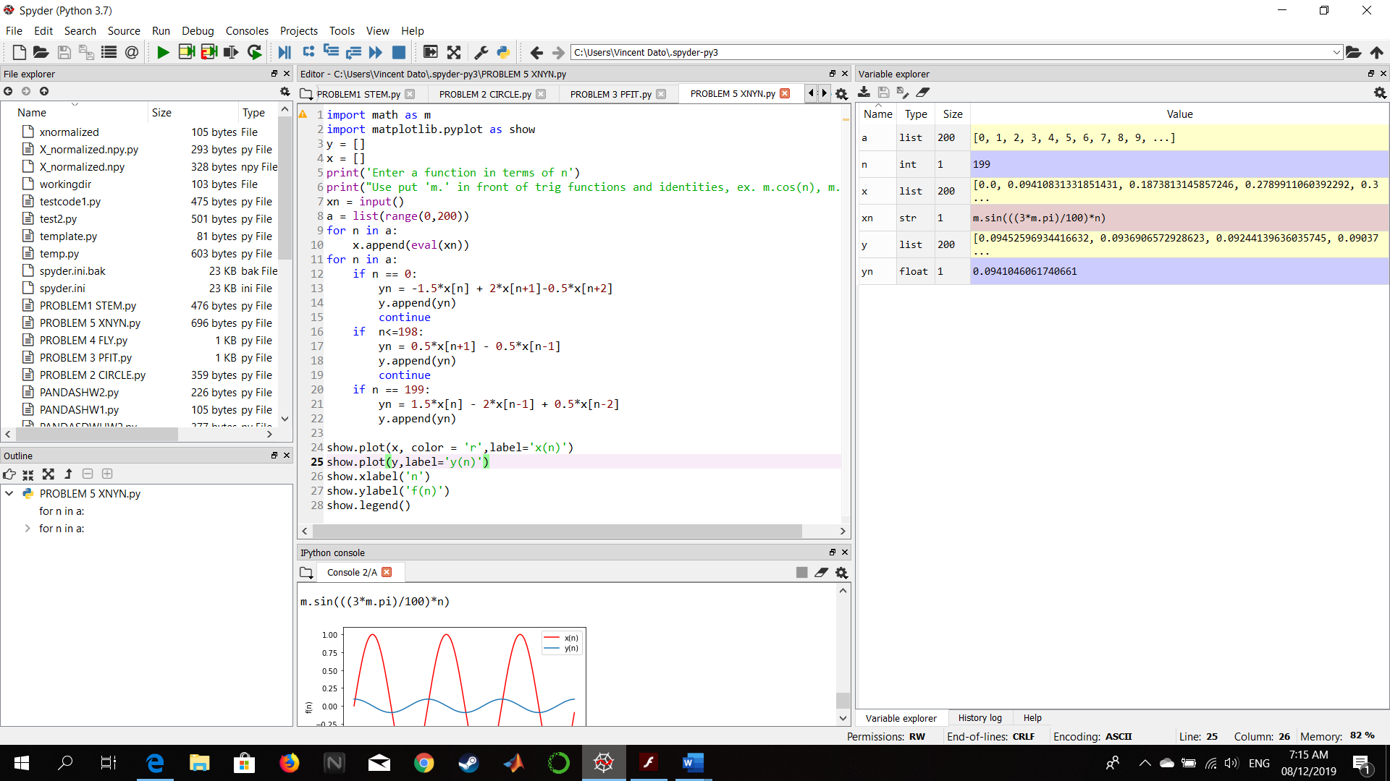PROBLEM 5 - Python

Figure :Screenshot of Codes and Output

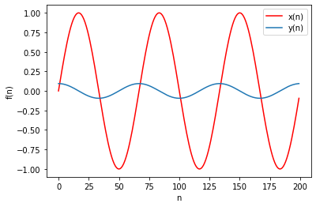

Figure :Output plot of superimposed x(n) and y(n)

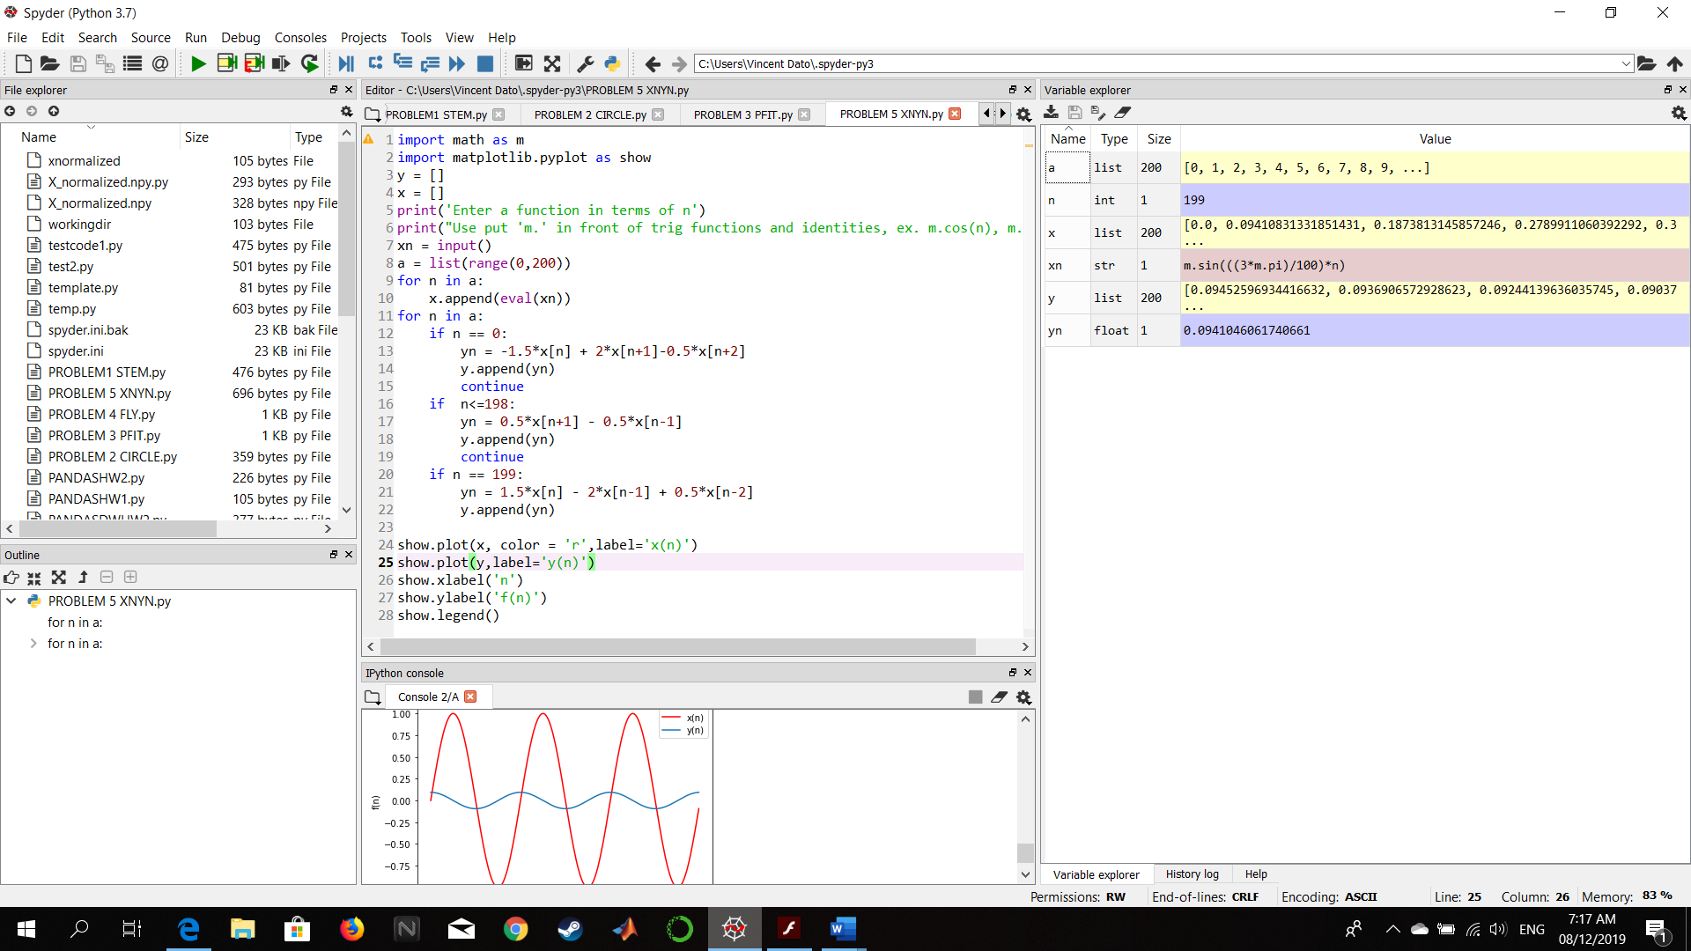

Figure :Used parameters with xn as user-defined input function of n